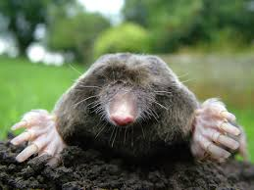
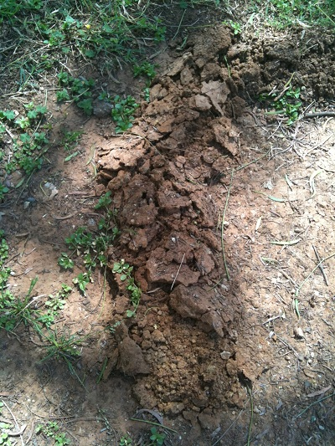
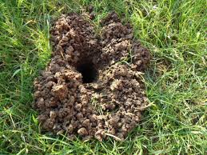
Talprid® Mole Bait

Talprid Kills Moles

Talprid is a product that has been scientifically designed and tested to mimic the appearance of earthworms, which is a natural food source for moles. This product is to be inserted into active mole tunnels and buried in order to successfully trick moles into consuming.  Each box contains 20 worms and should be stored on a flat surface in warm temperatures in order to keep their shape. |  | Talprid bait kills moles  Mimics a mole’s natural food source, the earthworm.

