A Brief Summary of SportsTurf Magazine’s Jan. 2020 Article by Casey Reynolds: “Natural Grass and Synthetic Turf Injury Research”

According to a 2018 market research study conducted in the United States and Canada by FleishmanHillard, a global PR firm and digital marketing agency based in St. Louis, “The safety and health of athletes is and should be a top priority for leagues, coaches, parents and others. However, what other factors are considered when installing new athletic fields? Is it maintenance, costs, environment, or other factors? Is it all of the above, and, if so, which factors play most heavily in these decisions?” We take a look in the January 2020 Issue of Sports Turf Magazine.
Casey Reynolds, PH.D. writes that, “Natural grass proponents and synthetic turf companies tout many of the same benefits including cost, environmental impact, durability and safety – many of consumers’ major concerns. They also analyzed the share of each group’s voice in digital media, as well as the positive, neutral and negative perceptions by subject for natural grass and artificial turf. One of the key items that jumped out was that it appears natural grass fields are taken for granted. There are fewer arguments for natural grass, rather than against artificial turf, because natural grass is in the default position. Artificial turf often gets more coverage and has non-neutral articles, in part simply because it is new and debated.”
People always ask the Question: Which type of Field is truly safer for the Athlete? Most of us in the Turfgrass Field already know the answer, but the results of the 2018 Study done by FleishmanHillard are quite shocking! Using the NCAA’s collected injury data through it’s Injury Surveillance System (ISS) since 1982 (Kerr et al 2014) and the NFL’s similar system since 1980 (Hershman et al 2012). FleishmanHillard found these results….
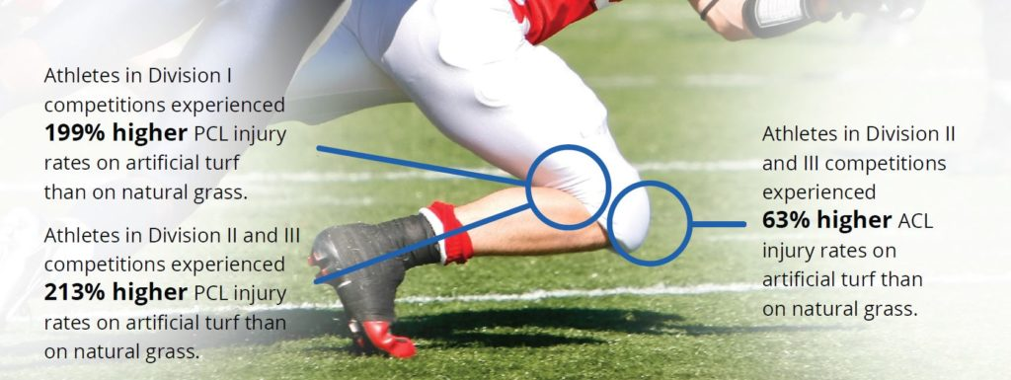
(Continued on back)

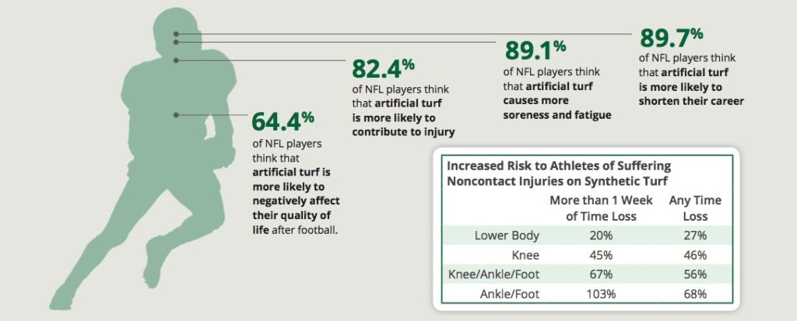

So, as you can clearly see, injuries to Athletes happen on Artificial Turf far more frequently than Natural Turf. But why exactly? The answer is simple: The Divot – Though we hate them on Golf Courses (And we hope you replace yours), divots on Athletic Fields are a GOOD Thing! When a Field is maintained correctly (not too dry/not too wet) it will allow the player to create a hole in the field allowing the force to be released from the Cleat to the Field rather than being absorbed by the player’s foot, ankle or knee which are the most commonly injured places on an Athlete’s body. Some Coaches might call that “Slipping”, but would they rather lose a few yards in one set of downs, or lose their star Running Back for the Season?

We at Eco Green Supply hope you share these facts with your friends and families and/or anyone who wants to go Synthetic over Natural Grass. As for the Cost/Maintenance (Synthetic vs. Natural Grass) debate, perhaps that will be next month’s Flyer? Stay tuned! For Casey Reynolds’ full article visit sportsturfonline.com/2020/01/03/natural-grass-and-synthetic-turf-injury-research/11008/
-Aron Adamczyk, Eco Green Supply
Citations
Hershman E, Anderson R, Bergfeld J, et al. An analysis of specific lower extremity injury rates on grass and FieldTurf playing surfaces in National Football League games. The American Journal of Sports Medicine. 2012; 40(10):2200-2205.
Kerr Z, Dompier T, Snook E, et al. National Collegiate Athletic Association Injury Surveillance System: review of methods for 2004-2005 through 2013-2014 data collection. J Athl Train. 2014;49(4):552-560.
Loughran, Galvin J., Vulpis, Christian T., Murphy, Jordan P., Weiner, David A., Svoboda, Steven J. Hinton, Richard Y., and Dave P. Milzman. Incidence of Knee Injuries on Artificial Turf Versus Natural Grass in National Collegiate Athletic Association American Football: 2004-2005 Through 2013-2014 Seasons. The American Journal of Sports Medicine 2019;47(6):1294–1301
Mack C, Hershman E, Anderson R, et al. Higher rates of lower extremity injury on synthetic turf compared with natural turf among National Football League athletes: epidemiologic confirmation of a biomechanical hypothesis. The American Journal of Sports Medicine. 2019;47(1):189-196
Casey Reynolds, Ph.D. Executive Director, Turfgrass Producers International “Natural Grass and Synthetic Turf Injury Research” -SportsTurf Magazine January 2020

